### Web Exploits

### Subtask 1

Scan Bodgeit in OWASP. You should find an XSS vulnerability in the app.

1. A screenshot showing the scan OWASP finding a XSS bug

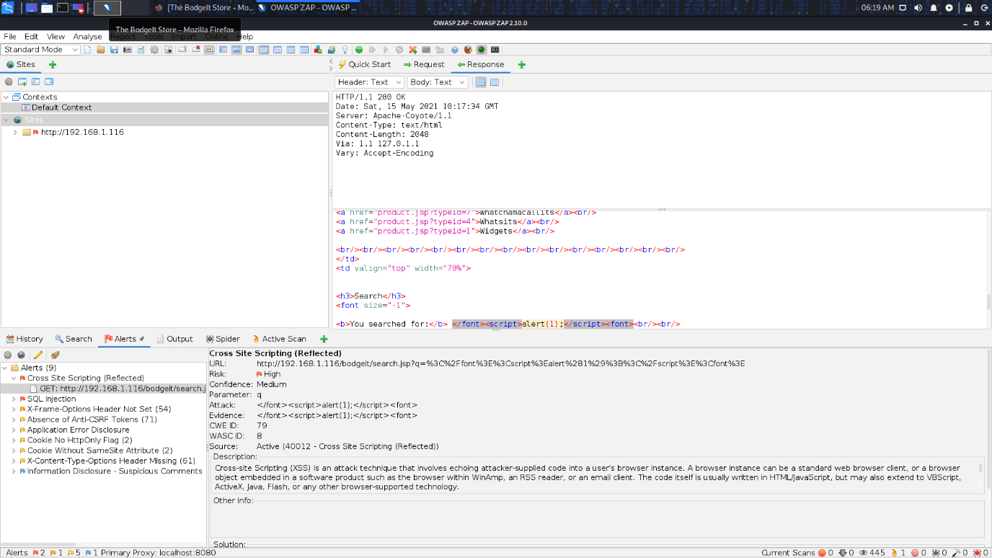

1. A screenshot showing you exploiting the bug.